Honey Brook Christian Academy



School Calendar 2025 - 2026

School cancellations and delays are announced on HBCA’s webpage  
[www.honeybrookchristianacademy.org](http://www.honeybrookchristianacademy.org)

HBCA sends schedule notifications and some other announcements during the school year as text messages. Please give us the cell number you want us to use. You can add yourself by texting the message **@HBCA** to   
(484) 722-4712.

Tuesday & Wednesday Aug. 19-20—Staff in-service

Monday, Aug. 25—First day of school (12:15 dismissal)

Thursday, Aug. 28 —Back-to-school night for students, teachers, & parents at 6:30 p.m.

Monday, Sept. 1—Labor Day Vacation, No school

Friday, Sept. 19 – staff in-service (11:30 dismissal)

*Tuesday, Sept. 23—First quarter interim (reports go home on Sept. 30)*

***Thursday, Oct. 23—End of first quarter (43 days, reports at P/T conferences)***

Tuesday, Oct. 28—Parent-teacher conferences (12:15 dismissal)

Friday, Nov. 14*—*staff in-service (11:30 dismissal)

*Friday, Nov. 21— Second quarter interim (reports go home on Dec. 4)*

Wednesday, Nov. 26*—* Thanksgiving Vacation (12:15 dismissal)

Thursday, Nov. 27 - Tuesday, Dec. 2—Thanksgiving Vacation unless snow makeup day (#1) (only Dec. 2)

Tuesday, Dec. 23—12:15 dismissal for Christmas Vacation

Wednesday, Dec. 24 - Friday, Jan. 2—Christmas Vacation

Subscribe to HBCA’s School Calendar  
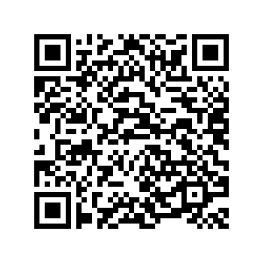 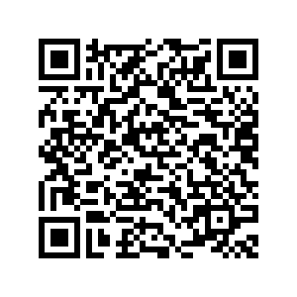  
 iCal Google Calendar

Monday, Jan. 5— First day of school in 2025

***Thursday, Jan. 8th—End of second quarter (43 days, reports at P/T conferences)***

Tuesday, Jan 13*—*Parent-teacher conferences (12:15 dismissal)

Monday, Jan. 19—MLK Vacation, No school unless snow makeup day (#2)

Friday, Jan. 30*—*staff in-service (11:30 dismissal)

*Monday, Feb. 9—Third quarter interim (reports go home on Feb. 18)*

Friday, Feb. 13 and Monday, Feb. 16—President’s Day Vacation, No school unless snow makeup day (#3, #4)

Tuesday, Mar. 10 and Wednesday, Mar. 11—IOWA achievement testing (Educational trips will not be granted during testing days for grades K-8)

***Friday, Mar. 13—End of third quarter (43 days, reports at conferences)***

Monday, Mar. 16—Friday, Mar. 20—Spring Break unless snow make-up (if more than 5 virtual school days are exceeded)

Tuesday, Mar. 24 —Parent-teacher conferences and re-enrollment meetings (12:15 dismissal)

Friday, April 3 and Monday April 6—Easter Vacation, no school unless snow makeup day (#5) (only April 6)

Friday, April 10*—*staff in-service (11:30 dismissal)

*Monday, April 20—Fourth quarter interim (reports go home on April 27)*

Thursday, May 21—School Picnic at 6:30 p.m.

***Friday, May 22—Last day of school, end of fourth quarter (43 days, 12:15 dismissal) reports will be mailed***

Sunday, May 24—Graduation Ceremony 6:30pm

Tuesday, May 26—Staff in-service