Honey Brook Christian Academy



School Calendar 2024 - 2025

School cancellations and delays are announced on HBCA’s webpage  
[www.honeybrookchristianacademy.org](http://www.honeybrookchristianacademy.org)

HBCA sends schedule notifications and some other announcements during the school year as text messages. Please give us the cell number you want us to use. You can add yourself by texting the message **@HBCA** to   
(484) 722-4712.

Tuesday, Aug. 20 and Wednesday, Aug. 21 —Staff in-service

Monday, Aug. 26—First day of school (12:15 dismissal)

Thursday, Aug. 29—Back-to-school night for students, teachers, & parents at 6:30 p.m.

Monday, Sept. 2—Labor Day—No school

Friday, Sept. 20 – staff in-service (11:30 dismissal)

*Tuesday, Sept. 24—First quarter interim (reports on Oct. 1)*

***Thursday, Oct. 24—End of first quarter (43 days, reports at conferences)***

Wednesday, Oct. 30—Parent-teacher conferences (12:15 dismissal)

Friday, Nov. 22*—*staff in-service (11:30 dismissal) *Second quarter interim (reports on Dec. 5)*

Wednesday, Nov 27*—* Thanksgiving Vacation (12:15 dismissal)

Thursday, Nov. 28 - Tuesday, Dec. 3—Thanksgiving Vacation unless storm make-up (only Dec 3; #1)

Friday, Dec. 20—12:15 dismissal

Subscribe to HBCA’s School Calendar  
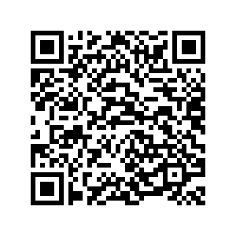 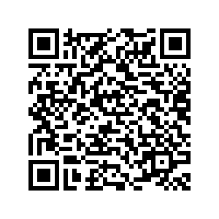  
 iCal Google Calendar

Monday, Dec. 23 - Wednesday, Jan. 1—Christmas Vacation

Thursday, Jan. 2— First day of school in 2025

***Thursday, Jan. 9th—End of second quarter (43 days, reports on Jan. 16)***

Monday, Jan. 20—MLK Vacation, No school unless snow makeup day (#2)

Friday, Jan. 31*—*staff in-service (11:30 dismissal)

*Monday, Feb. 10—Third quarter interim (reports on Feb. 18)*

Friday, Feb. 14 and Monday, Feb. 17—President’s Day Vacation, No school unless snow makeup day (#3, #4)

Tuesday, Mar. 11 and Wednesday, Mar. 12—IOWA achievement testing (Educational trips will not be granted during testing days for grades K-8)

***Friday, March 14—End of third quarter (43 days, reports at conferences)***

Monday, Mar. 17—Friday, Mar. 21—Spring Break unless snow make-up (if more than 5 virtual school days are exceeded)

Thursday, March 27 —Parent-teacher conferences (12:15 dismissal)

Friday, April 11*—*staff in-service (11:30 dismissal)

Friday, April 18th and Monday April 21—Easter Vacation, no school unless snow makeup day (only April 21; #5)

*Wednesday, April 23—Fourth quarter interim (reports on April 30)*

Thursday, May 22—School Picnic at 6:30 p.m.

***Friday, May 23—Last day of school, end of fourth quarter (43 days, 12:15 dismissal)***

Sunday, May 25—Graduation Ceremony at 6:30 p.m.

Tuesday, May 27—Staff in-service